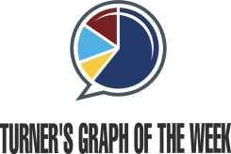
Intro to GOW Name:

Graph Topic:

- Limited Information:

- More Information:

- Observations:

- I predict that
because

_________________________________________________________________________________________________
Practice with Graph of the Week!
The TOPIC of this graph is: _______________________________________________________________________

This graph is about

The x-axis represents
The y-axis represents
The graph suggests that…

I predict that
because

